R081: Mood boards and Visualisation Diagrams

Name:

|  |  |  |
| --- | --- | --- |
| **A** | | **Mood boards: Content** |
| 1 | **Images** | |
| 2 | **Colours** | |
| 3 | **Colour schemes** | |
| 4 | **Fonts** | |
| 5 | ***Graphics*** | |
| 6 | *(digital only)* **Sound** | |
| 7 | *(digital only)* **Video** | |
| 8 | *(physical only)* **Fabrics** | |
| 9 | *(physical only)* **Materials** | |

|  |  |
| --- | --- |
| **B** | **Mood boards: Purpose** |
| 1 | *Generation* of ideas |
| 2 | *Development* of ideas |
| 3 | Communication of ideas with clients or colleagues |
| 4 | Creating a mood or feel |

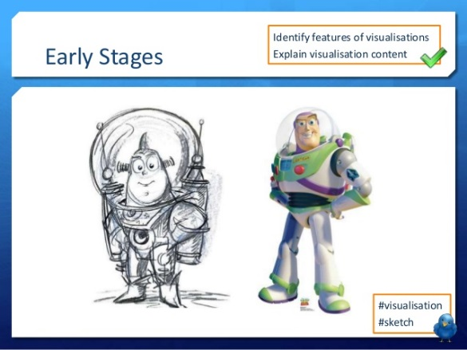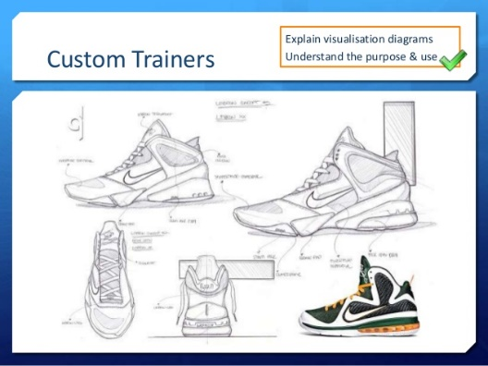

|  |  |  |
| --- | --- | --- |
| **D** | | **Visualisation Diagrams: Content** |
| 1 | **Drawn images** | |
| 2 | **Different viewpoints** (eg bird’s eye, plan etc) | |
| 3 | **Graphics** (eg logos, barcodes etc) | |
| 4 | **Layout** | |
| 5 | **Font** and style of text (not necessarily the content) | |
| 6 | **Annotations** showing details (eg size, interactivities, colours etc) | |

|  |  |  |
| --- | --- | --- |
| **F** | **Visualisation Diagrams: Key Vocab** | |
| **Graphics** | | Images made of simple shapes and colours |
| **Layout** | | The way parts of something are arranged |
| **Interactivity** | | The way something reacts with something else (eg what a button would do on a webpage) |

|  |  |
| --- | --- |
| **E** | **Visualisation Diagrams: Purpose** |
| 1 | Show how a finished item may look |
| 2 | Plan layout of a product visually |
| 3 | Show actions or interactivity |

|  |  |  |
| --- | --- | --- |
| **C** | **Mood boards: Key Vocab** | |
| **Generation** | | Creation |
| **Development** | | Gradual improvements |
| **Physical** | | On paper |
| **Digital** | | On screen |

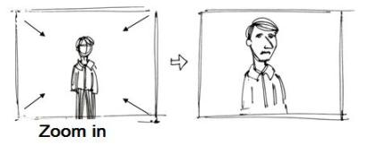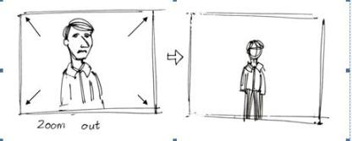

|  |  |  |
| --- | --- | --- |
| **B** | | **Story boards: Purpose** |
| 1 | Show how a moving visual product will look | |
| 2 | Help to plan camera positions, scenery, setting and props in production | |

|  |  |  |  |
| --- | --- | --- | --- |
| **A** | | | **Story boards: Content** |
| 1 | **Camera Shots** | | |
| 2 | **Camera Angles** | | |
| 3 | **Camera Movements** | | |
| 4 | **Scene content** (what’s happening) | | |
| 5 | **Annotations** (showing…) | | |
| 6 | | **Timings** | |
| 7 | | **Lighting effects** | |
| 8 | | **Sound effects** | |
| 9 | | **Location** | |
| 10 | | **Camera Type** | |

Name:

R081: Story boards

|  |  |  |
| --- | --- | --- |
| **C** | **Camera Vocab** | |
| **Camera Shots** | | |
| **Establishing shot** | | Wide angle including characters and setting |
| **Two shot** | | Shot including two characters in dialogue |
| **Close up** | | Shot of one character’s whole head |
| **Extreme close up** | | Shot of a particular detail (should be used sparingly) |
| **Camera Angles** | | |
| **Low angle** | | Shot from below, looking up at a character |
| **High angle** | | Shot from above, looking down at a character |
| **Mid angle** | | Shot showing the upper body and head of a character |
| **Wide angle** | | Shot including the whole body of a character |
| **Over shoulder** | | Shot with the back of a character’s shoulder and head in the foreground, putting the viewer in the scene |
| **Point of View** | | (normally hand held) shot as if the camera is the eyes of a character, putting the viewer in the position of the character |
| **Camera Movements** | | |
| **Zoom in** | | Camera stays still, but the image gets bigger |
| **Zoom out** | | Camera stays still, but the image gets smaller |
| **Pan** | | Camera stays still, but twists left or right |
| **Camera Type** | | |
| **Still** | | A still shot would not be moving |
| **Video** | | A normal moving image |
| **Virtual** | | An animated image |

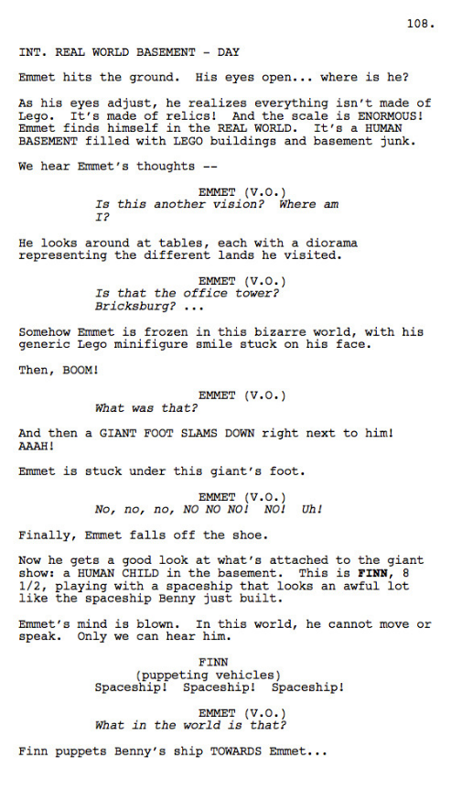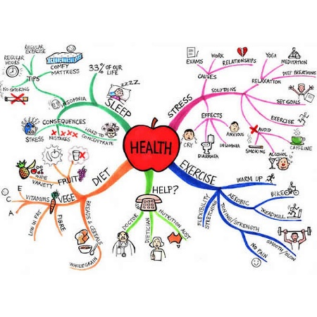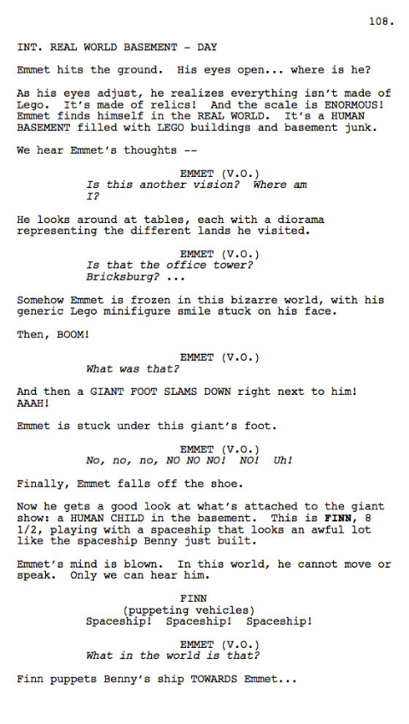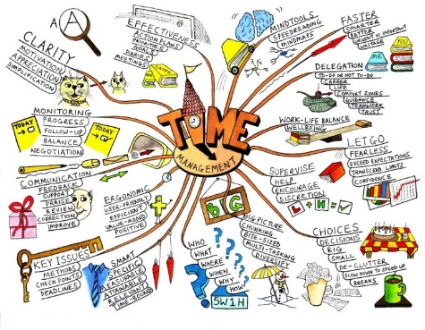

Name:

R081: Scripts and Mind Maps

|  |  |  |
| --- | --- | --- |
| **C** | **Scripts: Key Vocab** | |
| **Audio** | | To do with sound |
| **Audio-visual** | | Combining sound and pictures (ie films) |
| **Formatting** | | How the words are presented on the page |
| **Indentation** | | Set in from one side of a page |
| **Dialogue** | | Talking between characters |

|  |  |  |
| --- | --- | --- |
| **A** | | **Scripts: Content** |
| 1 | **Dialogue** | |
| 2 | **Stage directions** | |
| 3 | **Sound effects** | |
| 4 | **Names and details of characters** | |
| 5 | **Music or ambient sound** | |
| 6 | **Location** | |

|  |  |  |
| --- | --- | --- |
| **B** | | **Scripts: Purpose** |
| 1 | Show the dialogue and delivery directions for actors | |
| 2 | Indicate sound effects and scene requirements for production crew | |
| 3 | Outline of a production for clients, advertisers or any other stakeholders | |

|  |  |  |
| --- | --- | --- |
| **D** | | **Mind maps: Content** |
| 1 | **Central *node* with main theme** | |
| 2 | ***Sub-nodes* with related *general* ideas** | |
| 3 | **Sub-sub-nodes with *specific* ideas** | |
| 4 | ***Links* between nodes** | |
| 5 | **Text to show ideas** | |
| 6 | Sometimes **Images** | |

|  |  |  |
| --- | --- | --- |
| **E** | | **Mind maps: Purpose** |
| 1 | Generate ideas | |
| 2 | Develop ideas | |
| 3 | Visually display how ideas might relate | |

|  |  |  |
| --- | --- | --- |
| **F** | **Mind maps: Key Vocab** | |
| **Node** | | An idea in a mind map |
| **Sub-node** | | A node which is further away from the central node (ie *Menu* is a sub-node of *Website*. *Info* is a sub-node of *Menu)* |
| **Link** | | A connection between nodes |
| **General** | | Relating to lots of things |
| **Specific** | | Relating to few things |

|  |  |  |  |
| --- | --- | --- | --- |
| **E** | **Software** | | |
| **Image editing (photo)** | | Photoshop, GIMP, Publisher | *eg visualisation, image assets, moodboard* |
| **Image editing (vector)** | | Illustrator, InkScape | *eg visualisation, logo design, graphics* |
| **Word processing** | | Word, Google Docs | *eg scripts, documentation* |
| **Presentation software** | | Powerpoint, Google Slides | *eg visualisation diagram, moodboard* |

|  |  |  |
| --- | --- | --- |
| **C** | | **House Style** |
| 1 | **Fonts** | |
| 2 | **Colour schemes** | |
| 3 | **Logos** | |
| 4 | **Design styles** | |

|  |  |  |
| --- | --- | --- |
| **B** | | **Work Plan** |
| 1 | **Task** | |
| 2 | **Activity** | |
| 3 | **Work flow** | |
| 4 | **Timescale** | |
| 5 | **Resource** | |
| 6 | **Milestone** | |
| 7 | **Contingency** | |

Name:

R081: Planning Pre-Production

|  |  |  |  |
| --- | --- | --- | --- |
| **D** | **Planning: Key Vocab** | | |
| **Accessibility** | | The quality of being easily used by people with disabilities |  |
| **Work flow** | | The order the tasks have to be done in |  |
| **Milestone** | | A significant stage in a project, when a section is completed | *eg “All assets collected”* |
| **Contingency** | | Time set aside for if parts of the project run over schedule |  |
| **Asset** | | An individual part of a final product | *eg images, logos, sound files, text etc* |
| **Resource** | | Something used to create an asset | *eg laptop, Publisher etc* |
| **Primary source** | | Research collected directly by the person using it. | *eg questionnaires, meetings, etc* |
| **Secondary source** | | Research collected indirectly by the person using it. | *eg published reports, papers, websites etc* |
| **User requirement** | | What the client wants from the product | *eg “Must appeal to 20-30 year old men”* |
| **Constraint** | | Something that cannot happen | *eg cost less than £3,000* |
| **Digitise** | | Make a digital copy of a physical thing | *eg scan a drawing* |
| **Hardware** | | Physical resources | *eg scanner, laptop* |
| **Software** | | Computer programs which are used as resources | *eg Publisher, GIMP* |
| **House style** | | A set of rules for how documents or products will appear to ensure consistency | *eg Calibri, size 11, bold for titles, italics for examples* |

|  |  |  |
| --- | --- | --- |
| **A** | | **Target Audience Categories** |
| 1 | **Gender** | |
| 2 | **Age** | |
| 3 | **Ethnicity** | |
| 4 | **Income** | |
| 5 | **Location** | |
| 6 | **Accessibility** | |

|  |  |  |
| --- | --- | --- |
| **E** | | **Certifications** |
| BBFC | U, PG, 12, 12A, 15, 18 | |
| PEGI | 3, 7, 12, 16, 18 | |

|  |  |  |
| --- | --- | --- |
| **D** | | **Data Protection Act, 1998** |
| 1 | Fairly and lawfully processed | |
| 2 | Processed for limited purposes | |
| 3 | Adequate, relevant and not excessive | |
| 4 | Accurate | |
| 5 | Not kept for longer than necessary | |
| 6 | Processed in line with your rights | |
| 7 | Secure | |
| 8 | Not transferred to other countries without adequate protection | |

|  |  |
| --- | --- |
| **C** | **Risk Assessments: Contents** |
| Working at heights | |
| Slips, trips and falls | |
| Manual handling | |
| Cable safety | |

|  |  |  |
| --- | --- | --- |
| **A** | **Health and Safety: Key Vocab** | |
| **Risk Assessment** | | An examination of the risks and an attempt to mitigate against them |
| **Mitigate** | | Take steps to avoid something bad |
| **Recce** | | Visit to a location to help with planning |
| **Legislation** | | Laws |
| **Intellectual Property** | | Something non-physical which belongs to someone, *eg script, image, music, logo* |
| **Copyright©** | | Legal protection for intellectual property |
| **Trademark™** | | A word or phrase associated with a company |
| **Registered Trademark®** | | A trademark which has been registered, meaning misuse of it could be against the law |
| **Defamation** | | Bringing someone’s reputation into doubt. This can be illegal, and the offender can be sued |
| **Slander** | | Defamatory words which are publicly spoken |
| **Libel** | | Defamatory words which are written and published |
| **Certification** | | The minimum age a film or game is suitable for |
| **Copyright, Designs and Patents Act, 1988** | | Legislation which protects intellectual property by banning its unauthorised copying or redistribution |
| **Creative Commons** | | Organisation which issues licences which allow the public partial or total access |
| **Licence** | | A legal agreement about how an asset can be used or distributed |
| **Public Domain** | | Intellectual property with no copyright which is free for anyone to use |

|  |  |  |
| --- | --- | --- |
| **B** | | **Risk Assessments: Purpose** |
| 1 | Identify the hazards | |
| 2 | Identify who is at risk | |
| 3 | Identify the severity of the risks | |
| 4 | Help mitigate against risks | |
| 5 | Provide a record of what has been done | |

R081: Health and Safety

Name:

|  |  |  |  |  |  |  |  |  |  |
| --- | --- | --- | --- | --- | --- | --- | --- | --- | --- |
| **D** | **File types** | | | | | | | | |
| **PDF** | | document | lossless | cannot be edited |  | **MPEG** | video | lossy | high quality video |
| **DOCX** | | document | lossless | Word file |  | **MP4** | video | lossy | good for streaming online |
| **TXT** | | document | lossless | text only, no formatting |  | **MOV** | video | lossy | Quicktime Media Player format |
| **PNG** | | image | lossless | good compression for graphics |  | **MP3** | audio | lossy | high compression rate |
| **JPEG** | | image | lossy | good compression for images |  | **WAV** | audio | lossless | uncompressed |
| **GIF** | | image | lossy | normally used for animations |  | **SWF** | animation | lossy | good for streaming online |
| **BMP** | | image | lossless | uncompressed |  | **GIF** | animation | lossy | limited colour support |
| **SVG** | | image | lossless | cross application vector format |  | **FLV** | animation | lossy | Flash animation |
| **TIFF** | | image | both | high resolution raster images |  | **MOV** | animation | lossy | video formats can also be used |

|  |  |  |
| --- | --- | --- |
| **A** | **Storing Digital Graphics vocab** | |
| **Lossy** | | Compression of a file which loses some original data |
| **Lossless** | | Compression of a file which keeps all the original data |
| **Pixel** | | A single point of colour which makes up a bitmap image |
| **Resolution** | | The number of pixels in a certain area, often measured in dpi |
| **DPI** | | Dots per inch. A measure of resolution. The number of pixels in an inch. |
| **Compression** | | Reduction of a file size either by removing information (lossy) or without removing information (lossless) |
| **Bitmap** | | A method of storing an image. Each pixel’s value and position is recorded. Looks pixelated when enlarged |
| **Raster** | | Same as bitmap |
| **Vector** | | A method of storing an image. Details of where lines start and end, fills and colours are stored. Looks smooth when enlarged |

|  |  |  |
| --- | --- | --- |
| **C** | **Version Control** | |
| **Version Numbering** | | Graphics_mindmap_Ver1  Graphics_mindmap_Ver2  Graphics_mindmap_Ver3 |
| **Date code version control** | | Mitzy_script_22.1.20  Mitzy_script_29.1.20  Mitzy_script_3.2.20 |

|  |  |  |
| --- | --- | --- |
| **B** | **Working at a Computer** | |
| **Chair height** | | Eyes level with the display |
| **Seating position** | | Straight back, thighs parallel to the ground |
| **Distance from eyes to screen** | | About 50-60cm |
| **Breaks** | | Take a break for 1-2 mins every half hour to stretch |

R082: Storing Digital Graphics

Name: